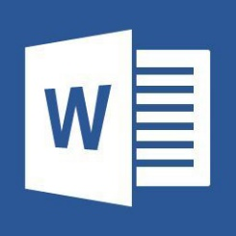

To view this content, please click "Enable Editing" form the yellow bar and then click "Enable Content"

Document created in earlier version of Microsoft Office Word